Wildfire influence on urban ozone: An observationally-constrained box modeling study at a site in the Colorado Front Range

Pamela S. Rickly^{1,2,*}, Matthew M. Coggon², Kenneth C. Aikin^{1,2}, Raul J. Alvarez II², Sunil Baidar^{1,2}, Jessica B. Gilman², Georgios I. Gkatzelis³, Colin Harkins^{1,2}, Jian He^{1,2}, Aaron Lamplugh⁴, Andrew O. Langford², Brian C. McDonald², Jeff Peischl^{1,2}, Michael A. Robinson^{1,2}, Andrew W. Rollins², Rebecca H. Schwantes², Christoph J. Senff^{1,2}, Carsten Warneke², and Steven S. Brown^{2,5}

¹Cooperative Institute for Research in Environmental Science, University of Colorado, Boulder, CO, USA
²NOAA Chemical Sciences Laboratory, Boulder, CO, USA
³Institute of Energy and Climate Research, IEK-8: Troposphere, Forschungszentrum Jülich GmbH, Jülich, Germany
⁴Institute of Behavioral Science, University of Colorado, Boulder, CO, USA
⁵Department of Chemistry, University of Colorado, Boulder, CO, USA
*Now at Air Pollution Control Division, Colorado Department of Public Health and Environment, Denver, CO, USA

Abstract. Increasing trends in biomass burning emissions significantly impact air quality in North America. Enhanced mixing ratios of ozone (O₃) in urban areas during smoke-impacted periods occurs through transport of O₃ produced within the smoke, or through mixing of pyrogenic volatile organic compounds (PVOCs) with urban nitrogen oxides (NO_{x} = NO + NO₂) to enhance local O₃ production. Here we analyze a set of detailed chemical measurements, including carbon monoxide (CO), NO_{x}, and speciated volatile organic compounds (VOCs), to evaluate the effects of smoke transported from relatively local and long-range fires on O₃ measured at a site in Boulder, Colorado, during summer 2020. Relative to the smoke-free period, CO, background O₃, OH reactivity, and total VOCs increased during both the local and long-range smoke periods, but NO_{x} mixing ratios remained approximately constant. These observations are consistent with transport of PVOCs (comprised primarily of oxygenates) but not NO_{x} with the smoke, and with the influence of O₃ produced within the smoke upwind of the urban area. Box-model calculations show that local O₃ production during all three periods was in the NO_{x}-sensitive (VOC-sensitive) regime. Consequently, this locally produced O₃ was similar in all three periods and was relatively insensitive to the increase in PVOCs. However, calculated NO_{x} sensitivities show that PVOCs substantially increase O₃ production in the transition and NO_{x}-saturated regimes. These results suggest 1) that O₃ produced during smoke transport is the main driver for O₃ increases in NO_{x}-sensitive urban areas and 2) that smoke may cause an additional increase in local O₃ production in NO_{x}-saturated (VOC-sensitive) urban areas. Additional detailed VOC and NO_{x} measurements in smoke impacted urban areas are necessary to broadly quantify the effects of wildfire smoke on urban O₃ and develop effective mitigation strategies.

Synopsis: Wildfire smoke contains ozone that enhances regional mixing ratios. Smoke VOCs may lead to additional local ozone production in regions that area NO_{x}-saturated (VOC-sensitive), but do not substantially increase urban ozone production in NO_{x}-sensitive regions.

1 Introduction

Tropospheric ozone (O₃) is a secondary pollutant formed by photochemical reactions involving nitrogen oxides (NO_{x} = NO + NO₂) and volatile organic compounds (VOCs). Ozone has the potential to cause adverse health effects through respiratory illness and contributes to global climate as a greenhouse gas. As a result, ozone has been established under the U.S. National Ambient Air Quality Standards (NAAQS) as a criteria pollutant with an exceedance value of 70 ppb over an 8-hour exposure period according to the most recent standard established in 2016. While the ozone standard has been reduced several times over the last two decades (U.S. Environmental Protection Agency, 2022), mitigation of O₃ can be difficult due to the evolving and non-linear relationship between NO_{x,} VOCs, and O₃. Urban NO_{x} emissions are primarily released from anthropogenic combustion sources, whereas VOCs are emitted from both biogenic and anthropogenic sources. Although urban O₃ concentrations have steadily declined in the U.S. in recent decades as a result of mitigation of anthropogenic emissions of these precursor species,¹ emissions of VOCs and NO_{x} from wildfires are expected to increase and play a more significant role in contributing to O₃ exceedances in a warming future.²
The frequency, duration, and intensity of western U.S. wildfires have shown dramatic increases since the 1980s.³⁻¹¹ The correlation of wildfire events is associated with warmer temperatures and longer dry seasons, as well as past fire suppression activities and increased fuel mass. Because these trends are projected to intensify under future climate scenarios, the wildfire season is expected to grow beyond the historical season of May – October.¹² A statistical analysis of fires between 1984–2018 indicate a doubling of fire events within the last half of this period and a quadrupling of the median annual area burned for the western U.S.⁷ These trends have significantly impacted air quality in the last two decades, for example with well-documented increases in particulate matter.¹³⁻¹⁷
The growth of the western U.S. wildfire season impacts urban O₃ mixing ratios through both local O₃ produced from the interactions of smoke with urban emissions, and transported O₃ formed by the chemistry of wildfire emissions.^{2, 18} There is strong evidence from recent statistical analyses in U.S. urban areas, including the Colorado Front Range, that associates enhanced summertime ozone with fire influence. Jaffe et al.¹⁹ found a mean O₃ increase at rural western U.S. sites of 2 ppbv per 1 million acres burned. The same group found an increase of 19-26 ppbv in daily maximum 8-hour average ozone (MDA8) during air pollution events in selected western U.S. cities²⁰ and determined that smoke influence was responsible for 31% of O₃ exceedances in a larger set of western U.S. cities²¹. Using a different method to assess smoke influence, Gong et al.²² found a 3-8 ppbv O₃ increase in 8 western U.S. cities. Brey et al.²³ examined smoke impact on O₃ across the continental U.S., finding higher ozone on smoke impacted days and a range of increased MDA8 of 3-36 ppbv associated with smoke. Buysse et al.²⁴ examined the relationship between PM_{2.5}, O₃ and NO_{x} in 18 western U.S. cities to show that O₃ increases with PM_{2.5} up to a mass loading of 30-50 µg m⁻³, then decreases at higher mass loadings, indicating a non-linear dependence of O₃ on smoke influence. These authors found no association between NO_{x} and smoke in urban areas, suggesting limited contribution of smoke to urban NO_{x}. In the Colorado Front Range urban areas, Lindass et al.²⁵ found a 10 ppbv average O₃ increase at a site outside of Boulder, CO after accounting for the relationship between O₃ and temperature. These authors did not find NO_{x} enhancements but did observe increases in peroxyacetyl nitrate (PAN), a NO_{x} reservoir species associated with smoke. A recent analysis in Boise, ID reached a similar conclusion.²⁶ Pollack et al.²⁷ found smoke influence on 13 of 41 O₃ exceedance days over the period 2017-2019 at another site near Boulder, CO and suggested the region was likely in the NO_{x}-sensitive O₃ formation regime on the basis of weekday-weekend O₃-NO_{x} relationships.
Boundary layer dynamics, transport and mixing complicate the observed relationships between fire influence and O₃. For example, O₃ lidar observations from a site in California’s central valley during the coastal Soberanes fire in 2016 showed 40-60 ppbv of transported O₃ enhancement at 1-3 km that did not appreciably mix within the boundary layer to influence surface O₃.²⁸ Similarly, aircraft measurements in California during the 2008 ARCTAS campaign found high levels of O₃ aloft from the mixing of urban and fire emissions.²⁹
Strategies to control urban O₃ production in the absence of smoke impacts have historically centered on analysis of VOC/NO_{x} sensitivity.³⁰ A region is classified as NO_{x}-sensitive when NO_{x} reductions more effectively reduce O₃ and NO_{x}-saturated (also referred to as VOC-sensitive) when VOC reductions more effectively reduce O₃. The point at which O₃ sensitivity is shifted between these regimes is referred to as the transition regime and highlights a change in the radical chemistry that drives O₃ production. A common tool for assessing O₃ sensitivity is a chemically explicit box model³¹⁻³³ constrained to observed NO_{x} and speciated VOCs and varied across plausible ranges of these inputs. Although box models have seen several applications to assess O₃ photochemistry in fire emissions,³⁴⁻³⁸ the approach has only recently been applied to understanding fire-impacted urban O₃ photochemistry.³⁹ An O₃ sensitivity box model analysis constrained to observations of speciated VOCs and NO_{x} in Bakersfield, CA during the summer of 2018 suggested that O₃ production there was NO_{x}-saturated / VOC-sensitive during non-smoky conditions, but became NO_{x} sensitive with the addition of PVOCs from wildfire smoke transported from northern CA during periods of enhanced O₃.
During the summer of 2020, smoke from local and long-range transported wildfire emissions significantly impacted the Colorado Front Range urban area. A detailed set of VOC and NO_{x} measurements was available in Boulder, CO as part of ongoing efforts to understand the impacts of emissions reductions associated with the response to the COVID-19 pandemic (the 2020 COVID Air Quality Study, COVID-AQS).⁴⁰ In this study, we exploit these detailed measurements to estimate O₃ production using a box modeling analysis. We calculate O₃ isopleths under varying VOC/NO_{x} ratios that are representative of the conditions typically observed in the Colorado Front Range urban area, and contrast these results to scenarios where smoke is mixed with urban VOCs and NO_{x}. This analysis provides a basis for understanding how photochemical ozone produced in the Colorado Front Range urban area responds to the introduction of wildfire smoke. The analysis may be more generally applicable to other smoke impacted urban areas based on both the increase in background O₃ transported with the smoke and the NO_{x}-dependence of local smoke influenced urban O₃ production.

2 Methods

2.1 Measurements

In-situ measurements were performed as part of the COVID-AQS field campaign aimed at studying changes in emissions in the Colorado Front Range urban area as a result of the COVID-19 lockdown. Measurements were conducted at a ground site located at the NOAA David Skaggs Research Center (DSRC) in Boulder, CO during two periods in spring (30 March – 30 June) and summer (21 July – 31 August) of 2020. Figure S1 shows a map of the site within the Colorado Front Range. Figure S2 shows meteorological conditions during different periods of smoke impact identified below. During the first period, emissions of NO_{x} from vehicles were significantly reduced relative to the same time period in pre-pandemic years. The second period had modestly reduced urban emissions (13% based on the FIVE inventory⁴¹) but included several episodes of significant smoke impacts. Here we utilize measurements acquired from 22 July through 24 August, 2020 when the Front Range region was subjected to periodic smoke transported from local and long-range wildfires.
An extensive suite of VOC measurements was conducted by proton transfer reaction time-of-flight mass spectrometry (PTR-ToF-MS) and gas chromatography mass spectrometry (GC-MS).^{42, 43} The PTR-ToF-MS is a chemical ionization mass spectrometer using H₃O⁺ reagent ions. It operates at 1 Hz to measure primary and secondary VOC species with a proton affinity greater than water at a detection limit of 10–100 pptv depending on the species. While the PTR-ToF-MS can offer measurements of a wide range of polar and unsaturated VOCs, the GC-MS complements these measurements by quantifying measurements of a wide suite of C2 to C10 organic compounds with isomer separation.⁴² The GC-MS utilizes cryogenic trapping through the use of Stirling coolers to preconcentrate analytes for enhanced sensitivity. This technique allows for measurements to be collected on a 20-minute time step with a detection limit <1 ppt and 1σ uncertainty <10%.⁴²
NO_{x} measurements were performed through laser-induced fluorescence detection of NO with a dual-channel system. The NO_{x} channel used a photolytic converter equipped with a 385 nm LED to convert NO₂ to NO with a conversion efficiency of 73%.⁴⁴ NO was excited in both channels using a rotationally resolved NO spectral feature near 215 nm and NO₂ was calculated using the difference between the two channels. The NO detection limit has been previously reported as 1 pptv at 1 Hz with an uncertainty of ± 6–9%.⁴⁵ The long sampling line length for these measurements allowed for a small percentage of NO to be converted to NO₂ through reaction with O₃ before reaching the sampling cells. A correction factor was applied to the dataset based on box model simulations using the NO, NO₂, and O₃ measurements. Briefly, the box model is used to generate a lookup table for the mixing ratio of NO that would be measured after 15 seconds of dark chemistry in the inlet. This table spans the range of NO and O₃ measured in the atmosphere, and we then used this table, along with the measured NO and O₃, to infer NO mixing ratios at the sample point. The NO_{x} measurements were also influenced by local NO_{x} emissions creating large spikes in the dataset throughout the day. To determine regional NO_{x} mixing ratios, a smoothing algorithm was applied to both the NO and NO₂ datasets by calculating a running median over an approximate 1.5-hour interval and removing any outliers (> 2 ppb from the median).
Ozone measurements were conducted by the Tunable Optical Profiler for Aerosol and oZone lidar (TOPAZ) instrument.^{46, 47} The TOPAZ lidar measures O₃ and aerosol backscatter profiles from about 20 m above ground level (AGL) to 6 – 8 km AGL at a time resolution of 10 min and with an effective vertical resolution (for O₃) ranging from ~10 m near the surface to about 900 m at the far end of the measurement range. The total uncertainty of the TOPAZ O₃ measurements increases from approximately 3 ppbv below 4 km AGL to about 10 ppbv at 8 km AGL. The lidar is also equipped with a commercial UV absorption monitor for in situ O₃ measurements (2B Technologies model 205) that continuously samples air at 5 m AGL. The in situ O₃ data are reported at 1-min time resolution.

2.2 Smoke influenced periods

Three characteristic periods were identified during this study: smoke-free, local smoke, and long-range transported smoke. In general, smoke transport times and OH exposure differentiate local smoke (shorter transport, lower OH exposure) from long-range smoke (longer transport, greater OH exposure). Here, we use chemical proxies for OH exposure, along with model output from the High-Resolution Rapid Refresh-Smoke (HRRR-Smoke) model, to differentiate these periods. Figure 1 highlights the chemical differences between each period by comparing short- and long-lived fire and urban tracer species. Here, benzonitrile is identified as a long-lived smoke tracer, furan is used as a short-lived smoke tracer, and maleic anhydride is used as a secondary product formed as a result of OH oxidation of furans and aromatic species present in smoke.⁴⁸ All smoke impacted periods had elevated benzonitrile. Local smoke had elevated furan and limited maleic anhydride, while long range smoke had elevated maleic anhydride but limited furan. Benzene, NO_{x}, and CO are present in both anthropogenic and smoke emissions, although NO_{x} from smoke is short-lived due to photochemical oxidation (photochemical lifetime as short as 0.3 hours³⁶) and is unlikely to be transported over appreciable distance with the smoke. These characterizations are further validated by HRRR-Smoke near-surface smoke forecasts (Fig. S3 and S5) as well as TOPAZ ozone and aerosol backscatter measurements (Fig. S7). We note that August 19 had a brief period of elevated furan and maleic anhydride, indicating mixed local and long-range smoke influence. This event is excluded from the analysis.
During the smoke-free period (22 July through 7 August), fire tracer species remain low, but urban tracers were present at mixing ratios that are typical for the Front Range.^{40, 49} An increase in fire tracers, such as benzonitrile, furan, and maleic anhydride, is observed during the smoke-influenced periods, which supports the characterization of local and transported smoke. Local smoke is identified based on the higher concentrations of furan compared to that of maleic anhydride (lifetimes $≤$ 4 hr and ~15 days, respectively),^{50, 51} which indicates recent emission of furan and the beginning of maleic anhydride secondary production, as discussed by Gkatzelis et al. (2022). These processes are favored in young biomass burning plumes. The identification of local smoke is supported by HRRR-Smoke simulations, which show that these periods were largely influenced by smoke transported from fires in Colorado located within 400 km of Boulder (Fig. S3). Local fires included Pine Gulch, Grizzly Creek, Cameron Peak and Williams Fork. Conversely, the long-range transported smoke period shows an opposite trend for furan and maleic anhydride, in which maleic anhydride is high as a result of secondary production during transport and furan has reacted away. The identification of long-range smoke is supported by HRRR-Smoke simulations which show that smoke during this period largely resulted from fires in Northern California (~1500 km from Boulder, Fig S5). California experienced a historic fire season in late 2020¹⁶, notably including the August complex fire that burned over 1 million acres. While NO_{x} remained relatively constant through each period, regional O₃ and CO mixing ratios increased during the local smoke period, followed by larger increases during the long-range transported smoke period.
A total of 16 days (22 July through 7 August) were identified as the smoke-free period. Four days (8, 9, 13, and 16 August) and three days (22–24 August) were identified as periods influenced by local smoke and transported smoke, respectively. The larger number of days for the smoke-free period provides a robust characterization of air quality in Boulder, CO during 2020. While there are a limited number of days for each smoke-influenced period, there is complete measurement coverage throughout each day, which allows for a reasonable assessment of ozone formation processes resulting from the mix of urban NO_{x} with PVOCs. Because each smoke influenced period occurred over a combination of weekends and weekdays, the smoke-free period also incorporates all weekends and weekdays.

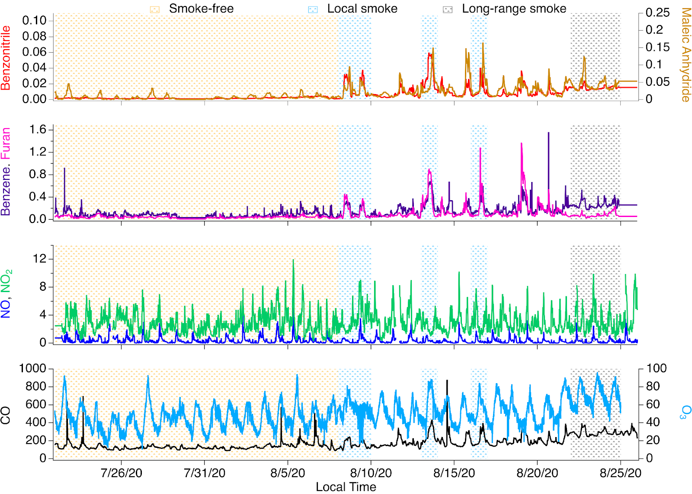
Figure 1. Time series of short- and long-lived fire tracer and urban tracer species, NO, NO₂, O₃, and CO highlighted by the fire tracer categorized periods of smoke influence. All mixing ratios are in parts per billion, ppb.

2.3 Box model implementation

The Framework for 0-D Atmospheric Modeling (F0AM v3.1) was used to analyze O₃ production under these three characteristic periods.³³ This Eulerian model is intended to represent the chemistry in air masses whose composition reflects either urban air or urban air mixed with varying levels of smoke. A modified VOC oxidation mechanism was applied based on the Master Chemical Mechanism v3.3.1 to include the chemistry of key PVOCs.^{48, 52, 53} Meteorological inputs were implemented from the Weather Research Forecasting with Chemistry (WRF-Chem) model, including pressure, temperature, relative humidity, and photolysis frequencies for key chemical species. The full description of The WRF-Chem setup is described by Li et al. ⁴¹. Briefly, WRF-Chem is configured at a horizontal spatial resolution of 12 km × 12 km over the continental US, with a total of 50 vertical layers extending from the surface to 50 hPa. The North American Mesoscale (NAM) model data was used to provide initial and boundary conditions for the meteorology in the model. We use the Madronich photolysis scheme to calculate photolysis rates. Generally, meteorological fields such as temperature, pressure, and relative humidity are reasonably estimated in our WRF-Chem model (Fig. S8). WRF-Chem surface pressure is systematically biased ~4% lower than ground measurements, likely due to challenges with modeling mountainous terrain ⁴¹. A key output from WRF-Chem are the photolysis frequencies, which account for photon attenuation by cloud coverage. Photolysis frequencies for NO₂, for example, correlate to University of Colorado pyranometer measurements of solar radiation with R² = 0.8 (Fig. S9).
In this analysis, we focus on model simulations between 7:00 and 16:00 local time when photochemical processes drive ozone formation. In-situ measurements and WRF-Chem meteorology were incorporated into the box model on 15-minute intervals. VOC mixing ratios, meteorological parameters, and photolysis frequencies were fully constrained to the median observations or modeling output from WRF-Chem. The model was also constrained by total NO_{x}, but NO and NO₂ were prescribed at each step using the F0AM function FixNOx described by Wolfe et al.³³. This function initializes modeled NO_{x} at each model step based on the measurement constraint, but maintains the modeled NO/NO₂ ratio. This assumption mitigates model artifacts that are not representative of regional, well-mixed models (such as NO titration of O₃) and results in improved O₃ simulations (Fig. S4).
Ozone mixing ratios were not constrained and were initialized with mixing ratios measured at midnight for each period. Physical losses of ozone by dilution during PBL expansion were estimated by multiplying a first-order dilution rate (k_{dil}) to the O₃ background observed within the Front Range region during each period – 29 ppb for smoke-free, 42 ppb for local-smoke, and 54 ppb for long-range transport. These background mixing ratios reflect the different amounts of ozone observed during periods of smoke influence and correspond to surface observations in the early morning hours before photochemistry begins.
Dilution rates were determined by varying k_{dil} until a best fit was observed between the model and measured O₃. The resulting dilution rate determined by this analysis was $8×{10}^{-5}$ s⁻¹ for the smoke-free and long-range smoke periods, and $1.1×{10}^{-4}$ s⁻¹ for the local smoke period. These rates are within 20% of that determined by previous box modeling analyses conducted within the Front Range ($1×{10}^{-4}$ s⁻¹).⁴⁹ We conduct sensitivity analyses for each model by varying the applied dilution rate by 20%, and incorporate these uncertainties into our model analyses as uncertainty bands.
The three main factors influencing modeled O₃ (NO_{x}, VOCs, and mixing ratios of background and initial O₃) were incorporated differently for the three periods of interest. The model was executed using the NO_{x} and meteorological parameters of the smoke-free period to simulate changes that would occur under base case conditions but with the addition of PVOCs; however, a discussion of NO_{x} for each period is presented in section 3.1.
Ozone isopleths were calculated by independently varying the VOC and total NO_{x} constraints applied to the model. To control for the effect of meteorology, each simulation uses the temperature, relative humidity, pressure and actinic flux from the smoke-free period, with VOC and NO_{x} constrained to the observations in each period and dilution tuned independently in each simulation. Fitted dilution rate constants varied by less than 25% between simulations. Here, we report noontime mixing ratios of O₃, NO_{x}, and VOCs when photochemistry was most active. We also determine O₃ sensitivity using model calculated relative radical termination rates, L_{n}/Q, as described by Robinson et al. ³⁶. The ratio of the NO_{x} influence on radical termination, L_{n}, relative to the total radical termination, Q, represents NO_{x}-saturation when L_{n}/Q > 0.5 and NO_{x}-sensitive when L_{n}/Q < 0.5.^{36, 54, 55} We note that the change in ozone sensitivity may occur at a value of L_{n}/Q slightly greater than 0.5 depending on the treatment of oxidized reactive nitrogen.

3 Results and discussion

3.1 NO_{x} comparison

Figure 2 shows NO_{x} measurements along with model simulations during each period. In general, NO_{x} did not significantly increase during smoke-impacted periods, which is consistent with previous measurements conducted along the Front Range during the wildfire season ²⁵. Daytime NO_{x} mixing ratios exhibited little variability, averaging 2–3 ppb for each period (see distributions in Figure 3, median NOx was 2.7, 2.6 and 2.3 ppb during no smoke, local smoke and long-range smoke periods, respectively). Morning rush hour NO_{x} was somewhat more variable (4.6, 6.1 and 6.5 ppb between 6:00-9:00 AM during smoke free, local smoke and long-range smoke periods, respectively), but we do not attribute this variation to smoke influence.

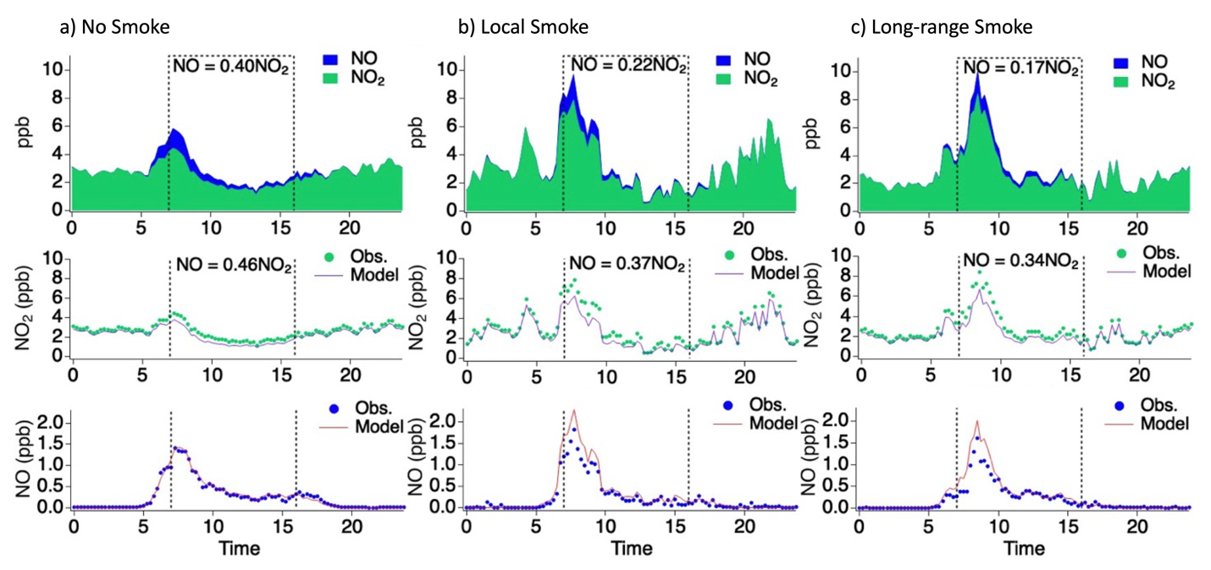
Figure 2. Panel showing measured NO and NO₂ in the top row, comparison of measured and modeled NO₂ in the middle row, and measured and modeled NO in the bottom row for the a) smoke-free, b) local smoke, and c) transported smoke periods. The top row shows the calculated NO/NO₂ ratio from the measurements and the middle row shows the calculated NO/NO₂ ratio from the model.

Model simulations of NO and NO₂ mixing ratios generally agree with the measurements, though small differences are observed (Fig. 2). Because the model allows the ratio of NO to NO₂ to vary while closely maintaining total measured NO_{x}, the observed daytime NO/NO₂ ratio differs from that of the model. The measurements suggest that the NO/NO₂ ratio varies by 60% between smoke-free and smoke-impacted periods, while the model suggests that these ratios only vary by 30%. The difference in this ratio between the measurements and model is likely the result of sampling artifacts due to the conversion of NO to NO₂ in the NO_{x} sampling line, as discussed in section 2.1. For example, higher ozone mixing ratios are observed during the smoke-impacted periods, which would bias NO_{x} measurements towards NO₂. Changes to photolysis rates may also affect model/measurement comparisons, since the pseudo steady-state approximation imposed by the FixNO_{x} constraint relies on a reasonable estimate of jNO₂. As described in Section 2.3, the modeling performed here uses photolysis frequencies derived from WRF-Chem, which did not account for photon attenuation resulting from the high concentration of aerosols in smoke.⁵⁶ We conducted a sensitivity analysis and reduced modeled photolysis frequencies by 20% to simulate photon attenuation previously reported in urban areas,⁵⁶ and observe a ~10% change to simulated NO, NO₂, and O₃. Consequently, the modeled NO/NO₂ ratio is likely within the measurement uncertainties.

3.2 VOC contribution

While NO_{x} remained largely the same between smoke-free and smoke-impacted periods, VOC mixing ratios and the distribution of VOC functionality changed substantially. The median total VOC carbon observed over each period was 53 ppb C for the long-range smoke, 51 ppb C for the local smoke, and 41 ppb C for the smoke-free period. Median CO mixing ratios also varied, and were observed to be of 288 ppb for long-range smoke, 176 for local smoke, and 127 ppb for smoke free periods (Fig. 3). Mixing ratios of oxygenated VOCs (OVOCs) measured during the fire-influenced periods were nearly twice as high as those measured during the smoke-free period (Fig. 3). The distribution of OVOCs is consistent with previous studies that reported a 60–80% OVOC contribution to total VOCs.⁵⁷⁻⁶² The OVOCs included in this analysis are summarized in Table S1.

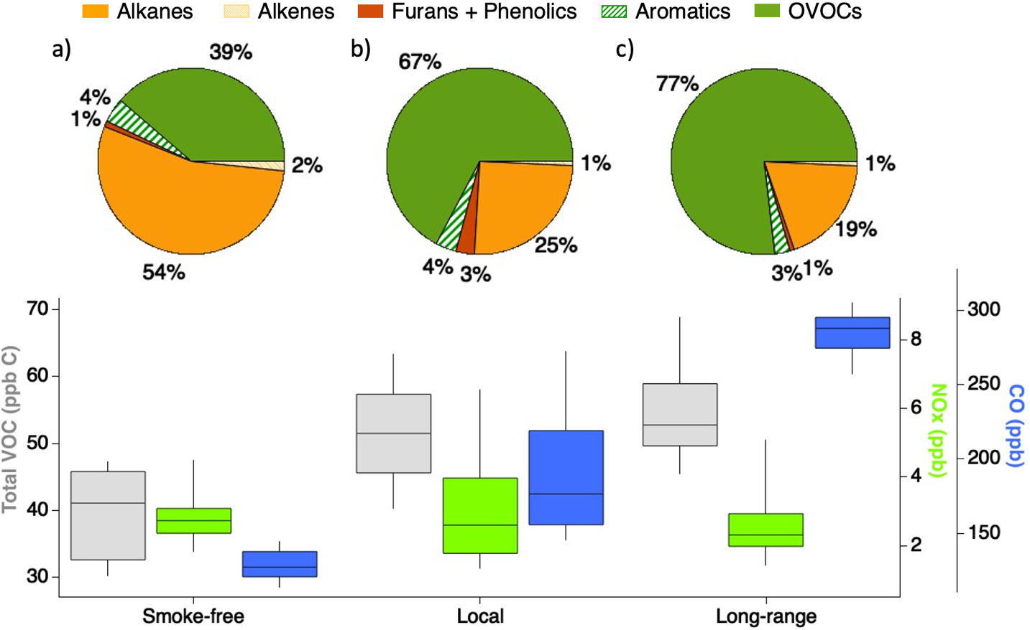
Figure 3. Box and whiskers plot of total VOCs, NO_{x}, and CO (bottom) with 90th and 10th percentiles shown by the whiskers and 75th and 25th percentiles shown by the box and (top) contribution of VOC functionalities to the total VOC mixing ratios observed for the a) smoke-free, b) local smoke, and c) long-range transported smoke periods.

The higher abundance of VOCs during the smoke-influenced periods results in a higher OH radical reactivity (OHR), which is an important quantity that relates to the production of organic radicals that contribute to ozone production. OHR is calculated following Eq. 1.

$OHR=k\left[CO\right]+k\left[NO2\right]+\sum{k_{i}{\left[VOC\right]}_{i} }$ (Eq. 1)

Here k is the OH rate constant for each gas-phase species, and [VOC] reflect the concentrations of measured VOCs plus those produced within the model that were not measured by PTR-ToF-MS or GC-MS (labeled “Other”, Fig. 4). Similar nighttime total OH reactivity is observed for the smoke-free and local smoke periods (4–5 s⁻¹). However, daytime local smoke OH reactivity increases to a maximum of 10 s⁻¹ and exhibits a diel average of 7.0 ± 1.8 s⁻¹. OH reactivity was observed to be consistently higher throughout the diel profile during the long-range smoke period, with an average of 8.0 ± 1.0 s⁻¹ and a brief increase midday to 10 s⁻¹. OVOCs, inorganics, and other VOC functionalities make up the largest contributions to the OH reactivity for each period. The larger inorganic fraction is primarily due to the enhanced CO concentrations, which is most prominent during the long-range transported smoke period. The increase in the OVOC contribution between the local smoke and transported smoke periods is the result of increased oxidation of primary species as the smoke is transported from the fire source, resulting in the largest contribution during the long-range smoke period.

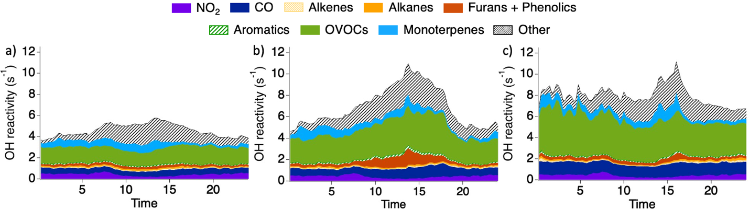
Figure 4. Calculated OH reactivity with model contributions from unmeasured secondary species for the a) smoke-free, b) local smoke, and c) long-range smoke periods.

3.2 O₃ production

Figure 5 shows model simulations of O₃ against the near-surface TOPAZ measurements. We focus on interpreting model performance based on the photochemical ozone enhancements - i.e., the amount of ozone produced at midday relative to the ozone minimum observed in the early morning. In general, each model reasonably captures photochemical O₃ enhancements during peak ozone production hours (7:00 - 16:00, local time). Although each model is constrained by significantly different VOC mixing ratios, the daily photochemical O₃ enhancement is similar within each period (30–35 ppb). This indicates that local photochemical ozone production did not significantly change with the influx of PVOCs during smoke-impacted periods. In contrast, baseline O₃ levels were more variable across the periods (Figures 1 and 5), which likely reflects differences in the amount of O₃ produced within the biomass burning plumes and subsequently transported to the Front Range urban area.^{36, 38, 63-65} The baseline O₃ concentration measured during the smoke-free period is ~29 ppb. This baseline concentration increases for the smoke-influenced periods to 42 ppb for local smoke and 54 ppb for long-range smoke, respectively. The increase in baseline O₃ during the long-range smoke period, along with photochemical ozone production, results in ozone non-attainment in Boulder, CO. During mid- to late-day periods, ozone levels exceeded the 70 ppbv 8-hour ozone standard for ~10 hrs starting around 14:00. This effect is reflected in both the daily profiles shown in Fig. 1 and the diurnal averages shown in Fig. 5.

Figure 5. (a-c) Measured and modeled diel O₃ profiles for the a) smoke-free, b) local smoke, and c) transported smoke periods. The uncertainty bands reflect 20% changes to the modeled dilution rates. (d,f) Corresponding O₃ isopleths. The black markers show the observed NO_{x} and ΣVOC mixing ratios.

The similarities in photochemical ozone production between each period suggests that the magnitude of the ozone production was not significantly influenced by PVOCs. This is supported by ozone isopleths which show that ozone production occurred within a NO_{x}-sensitive regime during both smoke-impacted and smoke-free periods (Fig. 5, panels d-f, and Fig. 6, panel a). NO_{x} in Boulder was not significantly different between each period (Figures 1-2) and photochemical ozone enhancements did not significantly change. However, the influx of PVOCs pushed the Front Range urban region further into a NO_{x}-sensitive regime, such that an increase in NO_{x} would have had a larger impact on ozone during smoke-impacted periods. Figure 6 illustrates this effect by showing the model response of midday O₃ enhancements (panels d–f) to changes in NO_{x} with fixed VOC concentrations (panel a) and VOC with fixed NO_{x} (panel b), where the base-case mixing ratios of VOC and NO_{x} are the makers in each isopleth from Fig. 5. Note that the scale in Fig. 6 extends to higher NO_{x} values than the isopleth shown in Fig. 5. As described in section 2.3, each simulation in Fig. 6 uses the same meteorology as the smoke-free period to facilitate comparison. Figure S10 shows simulations in which meteorology is constrained independently for each case, and in which only the VOC mixing ratios are allowed to vary. In all tests, the model shows that changes to the NO_{x} sensitivity curve during smoke-free and smoke-impacted periods are primarily driven by the introduction of PVOCs.

Fig. 6 shows that O₃ enhancements at the observed NO_{x} mixing ratios are similar for each case, which is also reflected in the model diurnal profiles (Fig. 5). Ozone production during the smoke-free period is closer to NO_{x}-saturation than the local or long-range smoke periods. In regions with higher urban NO_{x}, the model would predict greater local ozone production due to the shift in NO_{x} sensitivity resulting from the addition of PVOCs. For example, at NO_{x} mixing ratios of 5 ppb (three times the amount observed in Boulder), 51-53 ppbv of photochemical ozone would be expected for smoke-impacted periods, and 30 ppb for smoke-free periods. In contrast, ozone sensitivities to VOCs are similar for each period.

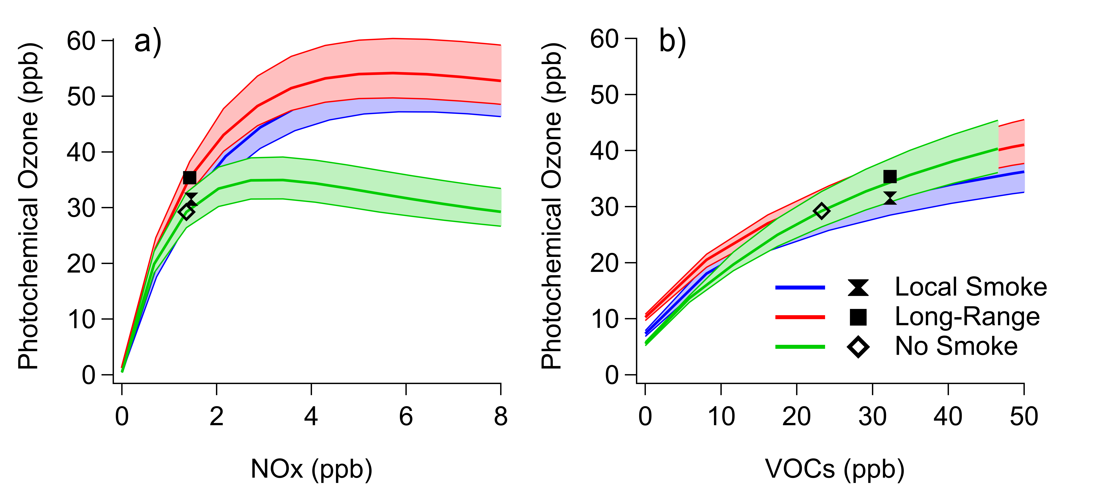
Figure 6. Modeled photochemical O₃ enhancement as a result of varied a) NO_{x} and b) VOCs. Markers show the observations at the Boulder, CO ground site. The uncertainty bands reflect 20% changes to the modeled dilution rates.

The NO_{x} sensitivity curve in Figure 6a shows Boulder to be in the NO_{x}-sensitive regime for all conditions in summer 2020. Because NO_{x} is heterogeneously distributed across regional scales, O₃ production in other areas of the Front Range may have been NO_{x}-saturated / VOC-sensitive with more rapid local ozone production rates during smoke influenced periods. For example, Lindass et al.²⁵ reported average daytime NO_{x} between approximately 2-10 ppbv at the Boulder Atmospheric Observatory (BAO), 30km to the Northeast of Boulder in 2015, while Pollack et al.²⁷ reported weekday NO_{x} in the 5-10 ppbv range over 2017-2019 at the Boulder Reservoir, in between the city of Boulder and the BAO. Daily average NO_{x} at the CAMP monitoring site in downtown Denver (39.7512, -104.9876) during the 2020 study was 13.5 ± 4.7 ppbv, well into the NO_{x} saturated region of Figure 6a. While the O₃ production in Boulder was exclusively NO_{x}-sensitive, it is likely that some parts of the region experienced NO_{x}-saturation and more rapid local O₃ production during smoke impacted periods This analysis suggests that urban areas with generally higher NO_{x} levels would be more susceptible to smoke influence on local ozone production, consistent with the statistical analysis of Brey and Fischer ²³ for the continental U.S. and Ninneman and Jaffe³⁹ for Bakersfield, CA. Presently, there are limited VOC and NO_{x} measurements available to assess the relationship between PVOCs and ozone across a range of urban NO_{x} conditions, and further work in regions representative of different chemical regimes would help to validate these modeling results.
Figure 6 shows ozone sensitivities during peak ozone production. Ozone sensitivities change throughout the day depending on radical production rates and the mixing ratios of NO_{x} and VOCs. Figure 7 shows similar trends in the diel variation in ozone production chemistry for each model based on the instantaneous L_{n}/Q calculation. Recall, L_{n}/Q > 0.5 reflects NO_{x}-saturation, while L_{n}/Q < 0.5 reflects NO_{x}-sensitivity ^{36, 54, 55}. Smoke-free and smoke-influenced periods exhibited NO_{x}-saturation during the morning rush hour (6:00–9:00), but then sustained NO_{x}-sensitive chemistry for the remainder of the day. An overall lower L_{n}/Q is observed during the daytime for the smoke-influenced periods indicating that the system is further into the NO_{x}-sensitive regime compared to the smoke-free periods, consistent with the isopleth analysis.

Figure 7. Modeled L_{n}/Q and ozone production rates for each simulation. L_{n}/Q provide instantaneous O₃ sensitivity estimates, in which a value >0.5 indicates NO_{x}-saturation and <0.5 indicates NO_{x}-sensitive. Ozone production rates are shown (For which period).

4 Implications for ozone mitigation

The model results suggest that local photochemical O₃ production, as analyzed at the Boulder site, is sensitive to urban NO_{x} reductions and that such reductions could represent an effective mitigation strategy during both smoke-free and smoke-impacted periods. Other areas within the Front Range with higher NO_{x} may exhibit saturation and higher local ozone production rates. A chemical transport model with sufficient spatial resolution and chemical specificity to represent NO_{x} heterogeneity, mixing of fire-impacted and urban air, and speciation and oxidation cycles of PVOCs is required to build on the approach presented here. In the absence of such a model, the simpler box modeling approach provides insight into the sensitivities and potential outcome of regional O₃ mitigation strategies under smoke-impacted conditions.
While these results are specific to the measurements in Boulder, CO, they may illustrate several general features of the response of urban O₃ to wildfire emissions. First, transported O₃ produced within the smoke upwind of the urban area can increase the baseline or background O₃, and, in combination with local O₃ production, may be sufficient to produce O₃ in excess of the 70 ppbv 8-hour O₃ NAAQS, as demonstrated in Boulder. Second, fires emit both NO_{x} and PVOCs, but pyrogenic NO_{x} is short-lived and unlikely to increase urban NO_{x} except for extremely local fires (i.e., a few hours of transport time). Pyrogenic VOCs, by contrast, do influence urban OH reactivity and ozone photochemistry. Third, local O₃ production is less sensitive to the input of PVOCs in urban areas that are in the NO_{x}-sensitive regime, but quite sensitive in the transition and NO_{x}-saturated / VOC-sensitive regimes. Understanding this NO_{x} sensitivity in the absence of smoke impact is critical to predicting the response of local O₃ production to wildfire emissions. Local NO_{x} reductions may mitigate smoke-induced local O₃ production, and this effect may vary across a given urban area.
Wildfire emissions impact attainment of O₃ standards across the U.S. and are likely to increase in importance in the immediate future with increasing pyrogenic emissions from western North American forests. Additional measurements and assessments of O₃ and CO enhancements associated with smoke outside of urban areas can help to quantify the influence of background or baseline O₃. Detailed VOC measurements and photochemical modeling that includes explicit chemical mechanisms for PVOC degradation can help to define NO_{x} sensitivities and influence of smoke on local O₃ production. These factors are required for the development of urban O₃ mitigation strategies that account for the influence of smoke.

Author Contributions
The manuscript was written through contributions of all authors. All authors have given approval to the final version of the manuscript.

Acknowledgement
PSR, KCA, SB, CH, JH, JP, MAR, and CJS acknowledge funding through the CIRES cooperative agreement NA17OAR4320101.

Data Availability
The data underlying this study are openly available in the COVID-AQS data repository (https://csl.noaa.gov/groups/csl7/measurements/2020covid-aqs/). University of Colorado pyranometer (https://skywatch.colorado.edu/) and meteorological data (https://sundowner.colorado.edu/weather/atoc1/) are produced by the Department of Atmospheric and Oceanic Sciences, and are also hosted on the COVID-AQS server.

References

1. Fleming, Z. L.; Doherty, R. M.; von Schneidemesser, E.; Malley, C. S.; Cooper, O. R.; Pinto, J. P.; Colette, A.; Xu, X.; Simpson, D.; Schultz, M. G.; Lefohn, A. S.; Hamad, S.; Moolla, R.; Solberg, S.; Feng, Z., Tropospheric Ozone Assessment Report: Present-day ozone distribution and trends relevant to human health. Elementa: Science of the Anthropocene 2018, 6.
2. Jaffe, D. A.; Wigder, N. L., Ozone production from wildfires: A critical review. Atmospheric Environment 2012, 51, 1-10.
3. Abatzoglou, J. T.; Williams, A. P., Impact of anthropogenic climate change on wildfire across western US forests. Proceedings of the National Academy of Sciences 2016, 113, (42), 11770-11775.
4. Dennison, P. E.; Brewer, S. C.; Arnold, J. D.; Moritz, M. A., Large wildfire trends in the western United States, 1984-2011. Geophysical Research Letters 2014, 2014GL059576.
5. Gutierrez Aurora, A.; Hantson, S.; Langenbrunner, B.; Chen, B.; Jin, Y.; Goulden Michael, L.; Randerson James, T., Wildfire response to changing daily temperature extremes in California’s Sierra Nevada. Science Advances 2021, 7, (47), eabe6417.
6. Higuera, P. E.; Shuman, B. N.; Wolf, K. D., Rocky Mountain subalpine forests now burning more than any time in recent millennia. Proceedings of the National Academy of Sciences 2021, 118, (25), e2103135118.
7. Iglesias, V.; Balch Jennifer, K.; Travis William, R., U.S. fires became larger, more frequent, and more widespread in the 2000s. Science Advances 2022, 8, (11), eabc0020.
8. Jain, P.; Castellanos-Acuna, D.; Coogan, S. C. P.; Abatzoglou, J. T.; Flannigan, M. D., Observed increases in extreme fire weather driven by atmospheric humidity and temperature. Nature Climate Change 2022, 12, (1), 63-70.
9. Juang, C. S.; Williams, A. P.; Abatzoglou, J. T.; Balch, J. K.; Hurteau, M. D.; Moritz, M. A., Rapid Growth of Large Forest Fires Drives the Exponential Response of Annual Forest-Fire Area to Aridity in the Western United States. Geophysical Research Letters 2022, 49, (5), e2021GL097131.
10. Pechony, O.; Shindell, D. T., Driving forces of global wildfires over the past millennium and the forthcoming century. PNAS 2010, 107, 19167-19170.
11. Westerling, A. L.; Hidalgo, H. G.; Cayan, D. R.; Swetnam, T. W., Warming and Earlier Spring Increase Western U.S. Forest Wildfire Activity. Science 2006, 313, (5789), 940-943.
12. Gillett, N. P.; Weaver, A. J.; Zwiers, F. W.; Flannigan, M. D., Detecting the effect of climate change on Canadian forest fires. Geophysical Research Letters 2004, 31, (18).
13. Burke, M.; Driscoll, A.; Heft-Neal, S.; Xue, J.; Burney, J.; Wara, M., The changing risk and burden of wildfire in the United States. Proceedings of the National Academy of Sciences 2021, 118, (2), e2011048118.
14. Graham, A. M.; Pringle, K. J.; Pope, R. J.; Arnold, S. R.; Conibear, L. A.; Burns, H.; Rigby, R.; Borchers-Arriagada, N.; Butt, E. W.; Kiely, L.; Reddington, C.; Spracklen, D. V.; Woodhouse, M. T.; Knote, C.; McQuaid, J. B., Impact of the 2019/2020 Australian Megafires on Air Quality and Health. GeoHealth 2021, 5, (10), e2021GH000454.
15. Knorr, W.; Dentener, F.; Lamarque, J. F.; Jiang, L.; Arneth, A., Wildfire air pollution hazard during the 21st century. Atmos. Chem. Phys. 2017, 17, (14), 9223-9236.
16. Li, Y.; Tong, D.; Ma, S.; Zhang, X.; Kondragunta, S.; Li, F.; Saylor, R., Dominance of Wildfires Impact on Air Quality Exceedances During the 2020 Record-Breaking Wildfire Season in the United States. Geophysical Research Letters 2021, 48, (21), e2021GL094908.
17. McClure, C. D.; Jaffe, D. A., US particulate matter air quality improves except in wildfire-prone areas. Proceedings of the National Academy of Sciences 2018, 115, (31), 7901.
18. Jaffe, D. A.; O’Neill, S. M.; Larkin, N. K.; Holder, A. L.; Peterson, D. L.; Halofsky, J. E.; Rappold, A. G., Wildfire and prescribed burning impacts on air quality in the United States. Journal of the Air & Waste Management Association 2020, 70, (6), 583-615.
19. Jaffe, D.; Chand, D.; Hafner, W.; Westerling, A.; Spracklen, D., Influence of Fires on O3 Concentrations in the Western U.S. Environmental Science & Technology 2008, 42, (16), 5885-5891.
20. Jaffe, D. A.; Wigder, N.; Downey, N.; Pfister, G.; Boynard, A.; Reid, S. B., Impact of Wildfires on Ozone Exceptional Events in the Western U.S. Environmental Science & Technology 2013, 47, (19), 11065-11072.
21. Lu, X.; Zhang, L.; Yue, X.; Zhang, J.; Jaffe, D. A.; Stohl, A.; Zhao, Y.; Shao, J., Wildfire influences on the variability and trend of summer surface ozone in the mountainous western United States. Atmos. Chem. Phys. 2016, 16, (22), 14687-14702.
22. Gong, X.; Kaulfus, A.; Nair, U.; Jaffe, D. A., Quantifying O3 Impacts in Urban Areas Due to Wildfires Using a Generalized Additive Model. Environmental Science & Technology 2017, 51, (22), 13216-13223.
23. Brey, S. J.; Fischer, E. V., Smoke in the City: How Often and Where Does Smoke Impact Summertime Ozone in the United States? Environmental Science & Technology 2016, 50, (3), 1288-1294.
24. Buysse, C. E.; Kaulfus, A.; Nair, U.; Jaffe, D. A., Relationships between Particulate Matter, Ozone, and Nitrogen Oxides during Urban Smoke Events in the Western US. Environmental Science & Technology 2019, 53, (21), 12519-12528.
25. Lindaas, J.; Farmer, D. K.; Pollack, I. B.; Abeleira, A.; Flocke, F.; Roscioli, R.; Herndon, S.; Fischer, E. V., Changes in ozone and precursors during two aged wildfire smoke events in the Colorado Front Range in summer 2015. Atmos. Chem. Phys. 2017, 17, (17), 10691-10707.
26. Lill, E.; Lindaas, J.; Juncosa Calahorrano, J. F.; Campos, T.; Flocke, F.; Apel, E. C.; Hornbrook, R. S.; Hills, A.; Jarnot, A.; Blake, N.; Permar, W.; Hu, L.; Weinheimer, A.; Tyndall, G.; Montzka, D. D. e.; Hall, S. R.; Ullmann, K.; Thornton, J.; Palm, B. B.; Peng, Q.; Pollack, I.; Fischer, E. V., Wildfire-driven changes in the abundance of gas-phase pollutants in the city of Boise, ID during summer 2018. Atmospheric Pollution Research 2022, 13, (1), 101269.
27. Pollack, I. B.; Helmig, D.; O'Dell, K.; Fischer, E. V., Weekend-Weekday Implications and the Impact of Wildfire Smoke on Ozone and Its Precursors at Boulder Reservoir, Colorado Between 2017 and 2019. Journal of Geophysical Research: Atmospheres 2021, 126, (17), e2021JD035221.
28. Langford, A. O.; Alvarez Ii, R. J.; Brioude, J.; Caputi, D.; Conley, S. A.; Evan, S.; Faloona, I. C.; Iraci, L. T.; Kirgis, G.; Marrero, J. E.; Ryoo, J.-M.; Senff, C. J.; Yates, E. L., Ozone Production in the Soberanes Smoke Haze: Implications for Air Quality in the San Joaquin Valley During the California Baseline Ozone Transport Study. Journal of Geophysical Research: Atmospheres 2020, 125, (11), e2019JD031777.
29. Singh, H. B.; Cai, C.; Kaduwela, A.; Weinheimer, A.; Wisthaler, A., Interactions of fire emissions and urban pollution over California: Ozone formation and air quality simulations. Atmospheric Environment 2012, 56, 45-51.
30. Seinfeld, J. H., Urban Air Pollution: State of the Science. Science 1989, 243, 745-752.
31. Emmerson, K. M.; Evans, M. J., Comparison of tropospheric gas-phase chemistry schemes for use within global models. Atmos. Chem. Phys. 2009, 9, 1831-1845.
32. Jenkin, M. E.; Saunders, S. M.; Pilling, M. J., The tropospheric degradation of volatile organic compounds: a protocol for mechanism development. Atmospheric Environment 1997, 31, (1), 81-104.
33. Wolfe, G. M.; Marvin, M. R.; Roberts, S. J.; Travis, K. R.; Liao, J., The Framework for 0-D Atmospheric Modeling (F0AM) v3.1. Geosci. Model Dev. 2016, 9, (9), 3309-3319.
34. Trentmann, J.; Yokelson, R. J.; Hobbs, P. V.; Winterrath, T.; Christian, T. J.; Andreae, M. O.; Mason, S. A., An analysis of the chemical processes in the smoke plume from a savanna fire. Journal of Geophysical Research: Atmospheres 2005, 110, (D12), n/a-n/a.
35. Müller, M.; Anderson, B. E.; Beyersdorf, A. J.; Crawford, J. H.; Diskin, G. S.; Eichler, P.; Fried, A.; Keutsch, F. N.; Mikoviny, T.; Thornhill, K. L.; Walega, J. G.; Weinheimer, A. J.; Yang, M.; Yokelson, R. J.; Wisthaler, A., In situ measurements and modeling of reactive trace gases in a small biomass burning plume. Atmos. Chem. Phys. 2016, 16, (6), 3813-3824.
36. Robinson, M. A.; Decker, Z. C. J.; Barsanti, K. C.; Coggon, M. M.; Flocke, F. M.; Franchin, A.; Fredrickson, C. D.; Gilman, J. B.; Gkatzelis, G. I.; Holmes, C. D.; Lamplugh, A.; Lavi, A.; Middlebrook, A. M.; Montzka, D. M.; Palm, B. B.; Peischl, J.; Pierce, B.; Schwantes, R. H.; Sekimoto, K.; Selimovic, V.; Tyndall, G. S.; Thornton, J. A.; Van Rooy, P.; Warneke, C.; Weinheimer, A. J.; Brown, S. S., Variability and Time of Day Dependence of Ozone Photochemistry in Western Wildfire Plumes. Environmental Science & Technology 2021, 55, (15), 10280-10290.
37. Lee, J. D.; Squires, F. A.; Sherwen, T.; Wilde, S. E.; Cliff, S. J.; Carpenter, L. J.; Hopkins, J. R.; Bauguitte, S. J.; Reed, C.; Barker, P.; Allen, G.; Bannan, T. J.; Matthews, E.; Mehra, A.; Percival, C.; Heard, D. E.; Whalley, L. K.; Ronnie, G. V.; Seldon, S.; Ingham, T.; Keller, C. A.; Knowland, K. E.; Nisbet, E. G.; Andrews, S., Ozone production and precursor emission from wildfires in Africa. Environmental Science: Atmospheres 2021, 1, (7), 524-542.
38. Wolfe, G. M.; Hanisco, T. F.; Arkinson, H. L.; Blake, D. R.; Wisthaler, A.; Mikoviny, T.; Ryerson, T. B.; Pollack, I.; Peischl, J.; Wennberg, P. O.; Crounse, J. D.; St. Clair, J. M.; Teng, A.; Huey, L. G.; Liu, X.; Fried, A.; Weibring, P.; Richter, D.; Walega, J.; Hall, S. R.; Ullmann, K.; Jimenez, J. L.; Campuzano-Jost, P.; Bui, T. P.; Diskin, G.; Podolske, J. R.; Sachse, G.; Cohen, R. C., Photochemical evolution of the 2013 California Rim Fire: synergistic impacts of reactive hydrocarbons and enhanced oxidants. Atmos. Chem. Phys. 2022, 22, (6), 4253-4275.
39. Ninneman, M.; Jaffe, D. A., The impact of wildfire smoke on ozone production in an urban area: Insights from field observations and photochemical box modeling. Atmospheric Environment 2021, 267, 118764.
40. Gkatzelis, G. I.; Gilman, J. B.; Brown, S. S.; Eskes, H.; Gomes, A. R.; Lange, A. C.; McDonald, B. C.; Peischl, J.; Petzold, A.; Thompson, C. R.; Kiendler-Scharr, A., The global impacts of COVID-19 lockdowns on urban air pollution: A critical review and recommendations. Elementa: Science of the Anthropocene 2021, 9, (1).
41. Li, M.; McDonald, B. C.; McKeen, S. A.; Eskes, H.; Levelt, P.; Francoeur, C.; Harkins, C.; He, J.; Barth, M.; Henze, D. K.; Bela, M. M.; Trainer, M.; de Gouw, J. A.; Frost, G. J., Assessment of Updated Fuel-Based Emissions Inventories Over the Contiguous United States Using TROPOMI NO2 Retrievals. Journal of Geophysical Research: Atmospheres 2021, 126, (24), e2021JD035484.
42. Lerner, B. M.; Gilman, J. B.; Aikin, K. C.; Atlas, E. L.; Goldan, P. D.; Graus, M.; Hendershot, R.; Isaacman-VanWertz, G. A.; Koss, A.; Kuster, W. C.; Lueb, R. A.; McLaughlin, R. J.; Peischl, J.; Sueper, D.; Ryerson, T. B.; Tokarek, T. W.; Warneke, C.; Yuan, B.; de Gouw, J. A., An improved, automated whole air sampler and gas chromatography mass spectrometry analysis system for volatile organic compounds in the atmosphere. Atmos. Meas. Tech. 2017, 10, (1), 291-313.
43. Yuan, B.; Koss, A.; Warneke, C.; Gilman, J. B.; Lerner, B. M.; Stark, H.; de Gouw, J. A., A high-resolution time-of-flight chemical ionization mass spectrometer utilizing hydronium ions (H3O+ ToF-CIMS) for measurements of volatile organic compounds in the atmosphere. Atmos. Meas. Tech. 2016, 9, (6), 2735-2752.
44. Pollack, I. B.; Lerner, B. M.; Ryerson, T. B., Evaluation of ultraviolet light-emitting diodes for detection of atmospheric NO2 by photolysis - chemiluminescence. Journal of Atmospheric Chemistry 2010, 65, (2-3), 111-125.
45. Rollins, A. W.; Rickly, P. S.; Gao, R. S.; Ryerson, T. B.; Brown, S. S.; Peischl, J.; Bourgeois, I., Single-photon laser-induced fluorescence detection of nitric oxide at sub-parts-per-trillion mixing ratios. Atmos. Meas. Tech. 2020, 13, (5), 2425-2439.
46. Alvarez, R. J.; Senff, C. J.; Langford, A. O.; Weickmann, A. M.; Law, D. C.; Machol, J. L.; Merritt, D. A.; Marchbanks, R. D.; Sandberg, S. P.; Brewer, W. A.; Hardesty, R. M.; Banta, R. M., Development and Application of a Compact, Tunable, Solid-State Airborne Ozone Lidar System for Boundary Layer Profiling. Journal of Atmospheric and Oceanic Technology 2011, 28, (10), 1258-1272.
47. Langford, A. O.; Alvarez Ii, R. J.; Kirgis, G.; Senff, C. J.; Caputi, D.; Conley, S. A.; Faloona, I. C.; Iraci, L. T.; Marrero, J. E.; McNamara, M. E.; Ryoo, J. M.; Yates, E. L., Intercomparison of lidar, aircraft, and surface ozone measurements in the San Joaquin Valley during the California Baseline Ozone Transport Study (CABOTS). Atmos. Meas. Tech. 2019, 12, (3), 1889-1904.
48. Coggon, M. M.; Lim, C. Y.; Koss, A. R.; Sekimoto, K.; Yuan, B.; Gilman, J. B.; Hagan, D. H.; Selimovic, V.; Zarzana, K. J.; Brown, S. S.; Roberts, J. M.; Müller, M.; Yokelson, R.; Wisthaler, A.; Krechmer, J. E.; Jimenez, J. L.; Cappa, C.; Kroll, J. H.; de Gouw, J.; Warneke, C., OH chemistry of non-methane organic gases (NMOGs) emitted from laboratory and ambient biomass burning smoke: evaluating the influence of furans and oxygenated aromatics on ozone and secondary NMOG formation. Atmos. Chem. Phys. 2019, 19, (23), 14875-14899.
49. McDuffie, E. E.; Edwards, P. M.; Gilman, J. B.; Lerner, B. M.; Dubé, W. P.; Trainer, M.; Wolfe, D. E.; Angevine, W. M.; deGouw, J.; Williams, E. J.; Tevlin, A. G.; Murphy, J. G.; Fischer, E. V.; McKeen, S.; Ryerson, T. B.; Peischl, J.; Holloway, J. S.; Aikin, K.; Langford, A. O.; Senff, C. J.; Alvarez, R. J.; Hall, S. R.; Ullmann, K.; Lantz, K. O.; Brown, S. S., Influence of oil and gas emissions on summertime ozone in the Colorado Northern Front Range. Journal of Geophysical Research: Atmospheres 2016, 121, (14), 8712-8729.
50. Bierbach, A.; Barnes, I.; Becker, K. H., Product and kinetic study of the oh-initiated gas-phase oxidation of Furan, 2-methylfuran and furanaldehydes at ≈ 300 K. Atmospheric Environment 1995, 29, (19), 2651-2660.
51. Chattopadhyay, A.; Papadimitriou, V. C.; Marshall, P.; Burkholder, J. B., Temperature-dependent rate coefficients for the gas-phase OH + furan-2,5-dione (C4H2O3, maleic anhydride) reaction. International Journal of Chemical Kinetics 2020, 52, (10), 623-631.
52. Decker, Z. C. J.; Robinson, M. A.; Barsanti, K. C.; Bourgeois, I.; Coggon, M. M.; DiGangi, J. P.; Diskin, G. S.; Flocke, F. M.; Franchin, A.; Fredrickson, C. D.; Gkatzelis, G. I.; Hall, S. R.; Halliday, H.; Holmes, C. D.; Huey, L. G.; Lee, Y. R.; Lindaas, J.; Middlebrook, A. M.; Montzka, D. D.; Moore, R.; Neuman, J. A.; Nowak, J. B.; Palm, B. B.; Peischl, J.; Piel, F.; Rickly, P. S.; Rollins, A. W.; Ryerson, T. B.; Schwantes, R. H.; Sekimoto, K.; Thornhill, L.; Thornton, J. A.; Tyndall, G. S.; Ullmann, K.; Van Rooy, P.; Veres, P. R.; Warneke, C.; Washenfelder, R. A.; Weinheimer, A. J.; Wiggins, E.; Winstead, E.; Wisthaler, A.; Womack, C.; Brown, S. S., Nighttime and daytime dark oxidation chemistry in wildfire plumes: an observation and model analysis of FIREX-AQ aircraft data. Atmos. Chem. Phys. 2021, 21, (21), 16293-16317.
53. Decker, Z. C. J.; Zarzana, K. J.; Coggon, M.; Min, K.-E.; Pollack, I.; Ryerson, T. B.; Peischl, J.; Edwards, P.; Dubé, W. P.; Markovic, M. Z.; Roberts, J. M.; Veres, P. R.; Graus, M.; Warneke, C.; de Gouw, J.; Hatch, L. E.; Barsanti, K. C.; Brown, S. S., Nighttime Chemical Transformation in Biomass Burning Plumes: A Box Model Analysis Initialized with Aircraft Observations. Environmental Science & Technology 2019, 53, (5), 2529-2538.
54. Kleinman, L. I., The dependence of tropospheric ozone production rate on ozone precursors. Atmos. Environ. 2005, 39, 575-586.
55. Kleinman, L. I.; Daum, P. H.; Lee, Y.-N.; Nunnermacker, L. J.; Springston, S. R.; Weinstein-Lloyd, J.; Rudolph, J., Ozone production efficiency in an urban area. Journal of Geophysical Research: Atmospheres 2002, 107, (D23), ACH 23-1-ACH 23-12.
56. Baylon, P.; Jaffe, D. A.; Hall, S. R.; Ullmann, K.; Alvarado, M. J.; Lefer, B. L., Impact of Biomass Burning Plumes on Photolysis Rates and Ozone Formation at the Mount Bachelor Observatory. Journal of Geophysical Research: Atmospheres 2018, 123, (4), 2272-2284.
57. Akagi, S. K.; Yokelson, R. J.; Wiedinmyer, C.; Alvarado, M. J.; Reid, J. S.; Karl, T.; Crounse, J. D.; Wennberg, P. O., Emission factors for open and domestic biomass burning for use in atmospheric models. Atmos. Chem. Phys. 2011, 11, (9), 4039-4072.
58. Burling, I. R.; Yokelson, R. J.; Griffith, D. W. T.; Johnson, T. J.; Veres, P.; Roberts, J. M.; Warneke, C.; Urbanski, S. P.; Reardon, J.; Weise, D. R.; Hao, W. M.; de Gouw, J., Laboratory measurements of trace gas emissions from biomass burning of fuel types from the southeastern and southwestern United States. Atmos. Chem. Phys. 2010, 10, (22), 11115-11130.
59. Christian, T. J.; Kleiss, B.; Yokelson, R. J.; Holzinger, R.; Crutzen, P. J.; Hao, W. M.; Shirai, T.; Blake, D. R., Comprehensive laboratory measurements of biomass-burning emissions: 2. First intercomparison of open-path FTIR, PTR-MS, and GC-MS/FID/ECD. Journal of Geophysical Research: Atmospheres 2004, 109, (D2).
60. Singh, H. B.; Chen, Y.; Staudt, A.; Jacob, D. J.; Blake, D.; Heikes, B.; Snow, J., Evidence from the Pacific troposphere for large global sources of oxygenated organic compounds. Nature 2001, 410, 1078-1081.
61. Yokelson, R. J.; Christian, T. J.; Karl, T. G.; Guenther, A., The tropical forest and fire emissions experiment: laboratory fire measurements and synthesis of campaign data. Atmos. Chem. Phys. 2008, 8, (13), 3509-3527.
62. Yokelson, R. J.; Karl, T.; Artaxo, P.; Blake, D. R.; Christian, T. J.; Griffith, D. W. T.; Guenther, A.; Hao, W. M., The Tropical Forest and Fire Emissions Experiment: overview and airborne fire emission factor measurements. Atmos. Chem. Phys. 2007, 7, (19), 5175-5196.
63. Baylon, P.; Jaffe, D. A.; Wigder, N. L.; Gao, H.; Hee, J., Ozone enhancement in western US wildfire plumes at the Mt. Bachelor Observatory: The role of NOx. Atmospheric Environment 2015, 109, 297-304.
64. Wigder, N. L.; Jaffe, D. A.; Saketa, F. A., Ozone and particulate matter enhancements from regional wildfires observed at Mount Bachelor during 2004–2011. Atmospheric Environment 2013, 75, 24-31.
65. Xu, L.; Crounse John, D.; Vasquez Krystal, T.; Allen, H.; Wennberg Paul, O.; Bourgeois, I.; Brown Steven, S.; Campuzano-Jost, P.; Coggon Matthew, M.; Crawford James, H.; DiGangi Joshua, P.; Diskin Glenn, S.; Fried, A.; Gargulinski Emily, M.; Gilman Jessica, B.; Gkatzelis Georgios, I.; Guo, H.; Hair Johnathan, W.; Hall Samuel, R.; Halliday Hannah, A.; Hanisco Thomas, F.; Hannun Reem, A.; Holmes Christopher, D.; Huey, L. G.; Jimenez Jose, L.; Lamplugh, A.; Lee Young, R.; Liao, J.; Lindaas, J.; Neuman, J. A.; Nowak John, B.; Peischl, J.; Peterson David, A.; Piel, F.; Richter, D.; Rickly Pamela, S.; Robinson Michael, A.; Rollins Andrew, W.; Ryerson Thomas, B.; Sekimoto, K.; Selimovic, V.; Shingler, T.; Soja Amber, J.; St. Clair Jason, M.; Tanner David, J.; Ullmann, K.; Veres Patrick, R.; Walega, J.; Warneke, C.; Washenfelder Rebecca, A.; Weibring, P.; Wisthaler, A.; Wolfe Glenn, M.; Womack Caroline, C.; Yokelson Robert, J., Ozone chemistry in western U.S. wildfire plumes. Science Advances 2021, 7, (50), eabl3648.

